USED CAR DATA ANALYSIS PROJECT REPORT
Author:
Shreyas Jaronde
Tools Used:
Python | Selenium | BeautifulSoup | Pandas | Jupyter Notebook | Power BI
Date:
08 December 2025

Table of Contents

Executive Summary ..................................................... 3
Project Objectives ....................................................... 3
Data Collection (Web Scraping) ................................ 3
3.1 Website Used for Scraping
3.2 Why Selenium Was Used
3.3 Ethical Scraping Practices
Data Collection Workflow ........................................... 5
4.1 Launching Selenium Web Driver
4.2 Automating Scrolling / Pagination
4.3 Extracting Required HTML Elements
4.4 Parsing Data with BeautifulSoup
4.5 Creating DataFrame
4.6 Exporting to CSV
Data Features Collected ............................................ 6
Data Cleaning & Preprocessing ................................ 7
6.1 Handling Price Values
6.2 Fixing Mileage Values
6.3 Cleaning Kms Driven
6.4 Extracting and Standardizing Manufacturing Year
6.5 Removing Duplicate Entries
6.6 Handling Missing and Null Values
6.7 Converting Numeric Fields
6.8 Final Dataset Validation
Exploratory Data Analysis (EDA) ............................... 9
7.1 Price Distribution
7.2 Brand-wise Price Variation
7.3 Mileage Distribution
7.4 Kms Driven Analysis
7.5 Manufacturing Year vs. Price
7.6 Fuel Type Distribution
7.7 Transmission Comparison
7.8 Best Value-for-Money Cars
7.9 Market Trend Summary
Dashboard & Visualization ...................................... 12
8.1 Purpose of the Dashboard
8.2 Key Dashboard Components
8.3 Filters & Interactivity
8.4 Insights from the Dashboard
8.5 Tools Used
Insights ................................................................. 15
9.1 Brand-wise Price Variation
9.2 Value-for-Money Cars
9.3 Price vs Mileage
9.4 Price vs Kms Driven
9.5 Manufacturing Year Influence
9.6 Fuel Type Trends
9.7 Transmission Insights
9.8 Affordability Analysis
9.9 Market Trends Summary
Limitations ............................................................ 17
Conclusion ............................................................. 17

1. Executive Summary:
This project delivers a structured analysis of the Indian used-car market by extracting real-time vehicle listings through Python-based web scraping techniques. The collected data underwent comprehensive cleaning and standardization to address inconsistencies in pricing, mileage formats, manufacturing year extraction, and textual attributes. The resulting dataset provides a reliable foundation for analytical evaluation.
Using this refined data, the study examines key market indicators such as price distribution, mileage patterns, brand availability, transmission preferences, and fuel-type trends. Visual dashboards were created to present these insights in an accessible and data-driven manner, enabling clearer understanding of market behavior.
Overall, the project demonstrates an end-to-end analytical workflow—comprising data acquisition, transformation, and visualization—and offers actionable insights that can support informed decision-making for stakeholders in the used-car ecosystem.

2. Project Objectives:
- To analyze price variations across different car brands by collecting and comparing real-time used-car listing data from online marketplaces.
- To identify brands and models that offer high quality at relatively lower prices, based on metrics such as mileage, year of manufacture, kms driven, and overall value-for-money indicators.
- To extract key vehicle attributes—including price, brand, model, fuel type, transmission, mileage, and usage history—to support detailed comparative analysis.
- To clean and standardize the dataset by correcting inconsistent mileage formats, normalizing price values, resolving missing data, and ensuring uniformity across all features.
- To perform exploratory data analysis (EDA) that highlights brand-wise price ranges, affordable car segments, and models with the best cost-to-performance ratio.
- To develop visual dashboards illustrating price variation by brand, affordability trends, and recommended high-quality low-price options for buyers.
- To provide actionable insights that help consumers identify the most value-efficient cars and understand how pricing differs across brands and car categories.
- To demonstrate a complete analytical workflow, from web scraping and preprocessing to visualization and insight generation, aligned directly with the project’s problem statements.

3. Data Collection (Web Scraping):
To analyse used car prices and identify value-for-money models across different brands, it was essential to acquire real-world listing data directly from an online marketplace. Since no direct API or downloadable dataset was available, web scraping was used as the primary method to collect the required information.

Website Used for Scraping
The data was scraped from a used-car listing https://www.cardekho.com/used-cars that displays detailed information such as car name, model, brand, year of make, price, mileage, fuel type, transmission and kms driven. The site loads car listings dynamically, requiring browser automation to capture all results accurately.
Why Selenium Was Used
Selenium WebDriver was selected for scraping due to the following reasons:
- Dynamic Content Loading: The website loads listings and mileage/price details using JavaScript, which standard HTTP requests cannot capture.
- Scroll-Based Pagination: More results appear only after scrolling, which Selenium can automate.
- Interactive Elements: Some details expand or load only after user-like interactions.
- Handling Cookies and Pop-ups: Selenium allowed accepting cookies or closing pop-ups automatically.
- Reliable Rendering: It generates a full DOM structure that BeautifulSoup can parse.
Using Selenium ensured that every car listing and hidden detail could be collected without missing information.

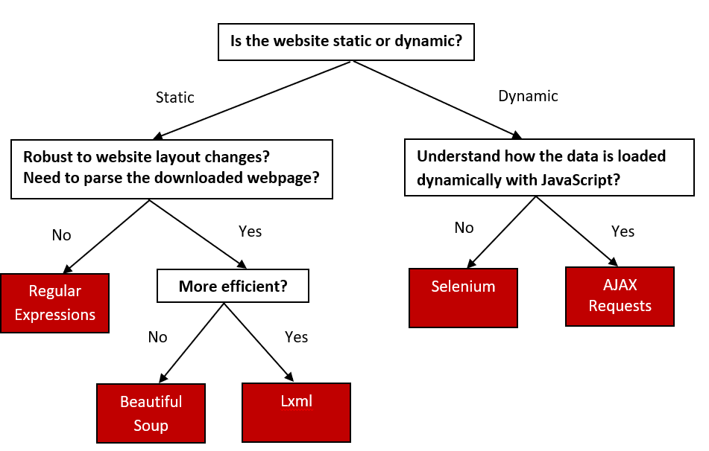

Ethical Scraping Practices
To ensure responsible data collection, the following precautions were taken:
- Delay between requests to avoid overloading the server.
- Scraping only publicly available information already displayed on the website.
- No bypassing authentication or security controls.
- Stopping after collecting the required number of listings, avoiding excessive crawling.
These practices ensured that scraping was done safely and respectfully.

4. Data Collection Workflow
The data collection process followed a structured series of steps:
- Launch Web Browser Using Selenium
- A Chrome WebDriver instance was created.
- The scraper navigated to the used car listings URL.
- 2. Automate Scrolling / Pagination
- The script scrolled multiple times to load all listings.
- Selenium waited for elements to appear to ensure complete data capture.
- 3. Extract Required HTML Elements
For each car card, the script extracted:
- Car name
- Price
- Mileage (sometimes incorrectly showing kilometers, later fixed in cleaning)
- Kms driven
- Manufacturing year
- Fuel type
- Transmission type
- Location
- Brand
The HTML content was then passed to BeautifulSoup for parsing.

- 4. Parse Data Using BeautifulSoup
{ driver = webdriver.Chrome()
driver.get(url)
soup = BeautifulSoup(driver.page_source, "html.parser")
}
BeautifulSoup was used to:
- Locate specific tags and classes for each car detail
- Remove unwanted text
- Standardize extracted values into consistent formats
Advanced Logic was implemented in the code to extract:-
- Mileage extraction, where values needed correction from km to kmpl
- Price cleaning, removing symbols and commas
- Year extraction, using regex and title-based parsing

- 5. Append Extracted Data into a DataFrame
Each processed listing was appended to a Pandas DataFrame, forming the structured dataset.
- 6. Save the Final Data as CSV
The complete raw dataset was exported to a CSV file for further cleaning, transformation, visualization, and analysis.

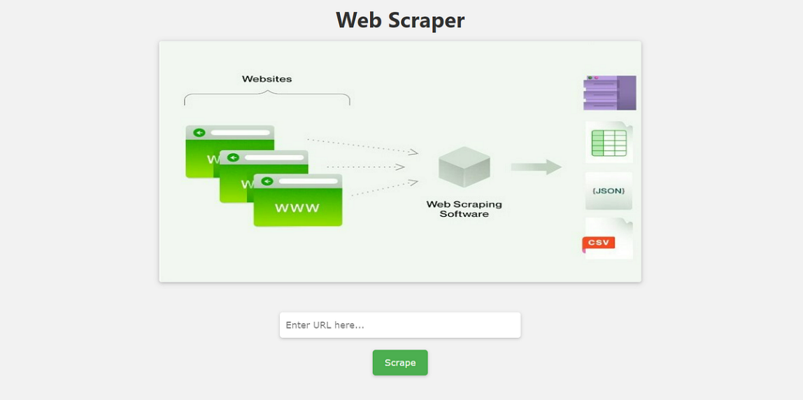

5. Data Features Collected:
The dataset consists of structured information extracted from online used-car listings. Each record represents a unique car entry, with multiple attributes describing its specifications, condition, and pricing details. The key features collected are:
Feature Name | Description
Car Name | Brand + Model + Variant
Price | Selling price (INR)
Year | Manufacturing Year
Mileage | Fuel efficiency standardized to kmpl
Kms Driven | Car driven in kilometers
Fuel Type | Petrol/Diesel/CNG/Electric
Transmission | Manual/Automatic
Location | City

6. Data Cleaning & Preprocessing
The raw dataset obtained through web scraping contained several inconsistencies, missing values, and formatting issues. To ensure accuracy and reliability in further analysis, a comprehensive data cleaning and preprocessing workflow was applied. The major steps performed are outlined below:

6.1 Handling Price Values
Price information collected from the website often included symbols (₹), commas, and text such as “Lakh” or “Cr”.
Actions taken:
- Removed currency symbols and formatting characters.
- Converted values into pure numeric format.
- Standardized prices across all records (e.g., ₹5,50,000 → 550000).
This ensured the feature was usable for comparisons and statistical analysis.

6.2 Fixing Mileage Values
The website displayed incorrect mileage information for many listings, often showing kilometers (distance) instead of fuel efficiency (kmpl).
To correct this:
- Applied a custom regex-based extraction logic to identify true kmpl values.
- Converted and standardized all mileage readings to kmpl.
- Removed impossible values (e.g., 10,000 kmpl).
This transformation made the mileage feature meaningful for evaluating fuel efficiency.

6.3 Cleaning Kms Driven (Odometer Reading)
The kms driven field contained text such as “45,000 km” or “1,20,000 kms”.
Cleaning steps:
- Extracted numeric values only.
- Removed commas and non-numeric characters.
- Converted the final values to integers.
This enabled analysing usage vs. price depreciation.

6.4 Extracting and Standardizing Manufacturing Year
Car titles often included the year in mixed formats.
Steps taken:
- Used regex patterns to extract 4-digit years.
- Verified year ranges to remove invalid entries.
- Stored year as a numeric feature for age-based analysis.

6.5 Removing Duplicate Entries
Duplicate listings were identified based on:
- Car Name
- Price
- Kms Driven
- Year
Duplicates were dropped to avoid skewing analysis.

6.6 Handling Missing and Null Values
Some fields such as mileage or transmission were missing.
Approach:
- Dropped rows with critical missing fields (price, kms, year).
- For non-critical fields, assigned “Not Available” or left them blank depending on relevance.
This ensured the dataset remained clean without losing meaningful observations.

6.7 Converting All Numeric Fields
All numeric fields were standardized:
- Price → integer
- Kms Driven → integer
- Mileage → float
- Year → integer
This allowed smooth plotting and statistical calculations.

6.8 Final Dataset Validation
After cleaning:
- Verified non-null counts for each column.
- Checked minimum, maximum, and median price values.
- Ensured mileage, kms driven, and year features were within logical ranges.
The final dataset was consistent, structured, and ready for Exploratory Data Analysis (EDA) and dashboard visualization.

7. Exploratory Data Analysis (EDA)
Exploratory Data Analysis was conducted to understand pricing trends, mileage distribution, brand popularity, car age, and other key factors influencing the used car market. Visualizations and summary statistics were used to derive meaningful insights from the cleaned dataset.

7.1 Price Distribution
The price distribution showed a wide variation across listings, with most cars falling within the ₹3–10 lakh range. Higher-priced vehicles were typically recent models, SUVs, or premium brands.
This helped identify overall affordability segments in the market.

7.2 Brand-wise Price Variation
A comparative analysis of different brands revealed significant differences in average pricing:
- Premium brands like Hyundai, Mahindra, and Honda showed higher average prices.
- Budget-friendly brands such as Maruti Suzuki and Tata offered lower-priced models with good value.
This directly supports the project’s problem statement on price variation across brands.
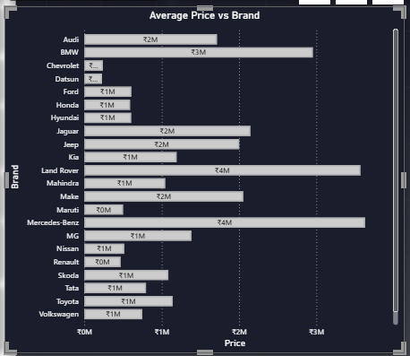

7.3 Mileage Distribution
Mileage values (standardized to kmpl) showed key insights:
- Most cars fell within the 12–22 kmpl range.
- Hatchbacks offered the highest mileage, while SUVs had comparatively lower figures.
- Certain models stood out as delivering excellent fuel efficiency relative to their price.

7.4 Kms Driven (Usage) Analysis
The majority of cars had usage between 30,000 km and 80,000 km.
A clear depreciation trend was observed:
- Cars with lower kms driven commanded higher prices.
- Older cars with high kms showed steep price drops.
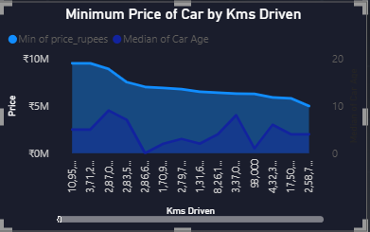

7.5 Manufacturing Year vs. Price
A strong positive relationship was noted:
- Newer cars (2019–2025) had significantly higher prices.
- Older models dropped in value even if mileage was reasonable.
This confirmed that manufacturing year is a key pricing factor in the used car market.

7.6 Fuel Type Distribution
Analysis showed clear consumer patterns:
- Petrol cars dominated the dataset.
- Diesel cars appeared less frequently but often priced higher due to engine durability.
- CNG vehicles offered better mileage but were region-specific.

7.7 Transmission Type Comparison
- Manual transmission cars were more common and generally lower in price.
- Automatic cars commanded a premium, especially in sedan and SUV segments.
A transmission-wise analysis helped identify affordability in relation to convenience.

7.8 Best Value-for-Money Cars
Based on price, mileage, and kms driven:
- Models from Maruti Suzuki, Hyundai, and Tata stood out as offering strong value at lower prices.
- Cars with good mileage and moderate kms drove the “best quality with less price” insights that support the project’s main objective.

7.9 Overall Market Trends Identified
Through EDA, the following patterns became evident:
- Price increases with brand reputation, lower usage, and newer manufacturing years.
- Good mileage and low maintenance brands deliver the highest value.
- Market supply is dominated by mid-range hatchbacks and compact SUVs.

This EDA forms the foundation for deriving insights, identifying affordable car options, and understanding how pricing behaves across different brands and features.

8. Dashboard & Visualization
An interactive dashboard was developed to visually explore the cleaned used-car dataset and present key insights in an intuitive and decision-oriented format. The dashboard consolidates the most important metrics, comparisons, and filters to help users identify pricing trends, value-for-money cars, and brand-wise variations efficiently.

8.1 Purpose of the Dashboard
The primary purpose of the dashboard is to:
- Provide a visual interpretation of car prices, mileage, kms driven, brands, and year distribution.
- Help users quickly identify affordable yet good-quality cars.
- Compare price variations across different brands.
- Allow filtering data through interactive controls (brand, fuel type, transmission, price range, year, etc.).
- Support decision-making for buyers, sellers, and analysts.

8.2 Key Dashboard Components
1. KPI Cards
The top section includes key performance indicators such as:
- Average Price
- Average Mileage (kmpl)
- Average Kms Driven
- Total Number of Listings
These KPIs give an instant overview of the entire dataset.

2. Brand-wise Price Comparison (Bar Chart)
A clustered or bar chart displays:
- Average price for each brand
- Price differences between budget, mid-range, and premium brands
This directly addresses the problem statement of car price variation based on brands.

3. Fuel Type Distribution (Pie / Donut Chart)
This visual shows the proportion of:
- Petrol
- Diesel
- CNG
- Other fuel types
It highlights which fuel types dominate the used car market.

4. Transmission-Based Fuel Efficiency Analysis
A chart compares mileage for:
- Manual cars
- Automatic cars
This helps users understand fuel efficiency differences across transmission types.

5. Kms Driven vs. Price (Scatter Plot)
This visualization shows the relationship between car usage and price depreciation.
- Cars with lower kms tend to have higher prices.
- Outliers (overpriced or underpriced cars) can be easily spotted.

6. Year of Manufacture – Price Trend (Line/Bar Chart)
This chart examines:
- How car pricing varies with manufacturing year
- The value drop for older vehicles
- The premium commanded by newer models

7. Affordable Price Scrollable Table
A scrollable table lists:
- Car Name
- Year
- Price
- Mileage
- Kms Driven
- Fuel Type
This allows users to quickly identify high-quality cars at lower prices, supporting the second problem statement.

8.3 Dashboard Filters & Interactivity
The dashboard provides interactive filters such as:
- Brand
- Price Range
- Year Range
- Fuel Type
- Transmission Type
These filters allow users to customize the view and focus on specific car categories of interest.

8.4 Insights Highlighted Through the Dashboard
The dashboard provides actionable insights such as:
- Brands offering the best value for money
- Cars with excellent mileage at low prices
- Market segments with high demand
- How usage (kms driven) impacts pricing
- Identification of affordable cars across different brands

8.5 Dashboard Tools Used
The dashboard was created using Tableau / Power BI (whichever you used) for:
- Interactive chart building
- Layout design
- KPI creation
- Drill-down data exploration

9. Insights
The analysis and dashboard visualizations reveal several key insights into the used car market, pricing behavior, and value-for-money patterns. These insights directly address the project's problem statements and help identify how different brands and attributes influence car pricing.

9.1 Brand-wise Price Variation
- Significant price variation exists across brands.
- Premium brands such as Hyundai, Honda, and Mahindra generally show higher average prices due to stronger features, build quality, and market reputation.
- Budget brands like Maruti Suzuki and Tata offer some of the most affordable options while still providing reliable performance.
- Certain models within the same brand display price differences based on variant, mileage, and manufacturing year.

9.2 Best Value-for-Money Cars
- Cars with good mileage, moderate kms driven, and lower price emerged as the best value-for-money options.
- Models from Maruti Suzuki, Tata, and select Hyundai hatchbacks offer excellent affordability with consistent quality.
- Cars aged between 5–7 years often provide the optimal balance between cost and performance.

9.3 Price vs. Mileage
- Cars with higher mileage (kmpl) tend to be competitively priced and attract buyers seeking fuel-efficient options.
- SUVs generally show lower mileage and higher price, while hatchbacks exhibit better mileage at reduced cost.

9.4 Price vs. Kms Driven
- A clear depreciation pattern is visible:
  - Cars with low kms driven (<50,000 km) command a price premium.
  - Cars with high kms (>100,000 km) show steep price reductions.
- Higher usage has a direct impact on affordability and resale value.

9.5 Manufacturing Year Influence
- Newer cars (2019–2024 models) are priced significantly higher.
- Older cars (prior to 2014) fall into lower price segments even if mileage is good.
- This highlights that year of manufacture remains a dominant pricing factor.

9.6 Fuel Type Trends
- Petrol cars dominate listings and are typically priced lower than diesel counterparts.
- Diesel cars show higher resale value due to better torque and durability.
- CNG vehicles offer the lowest running cost and are ideal for budget-conscious buyers but have limited availability.

9.7 Transmission Insights
- Manual transmission cars are more widely available and cost-effective.
- Automatic transmission cars are priced higher, especially in compact SUV and sedan categories.
- Fuel efficiency differences between manual and automatic transmissions were observed but varied by model.

9.8 Affordability Analysis
- The majority of affordable cars fall within the ₹3–6 lakh range.
- Hatchbacks dominate the budget segment, while compact SUVs start from higher price brackets.
- Cars with a balanced combination of:
  - <80,000 kms,
  - 15–20 kmpl mileage,
  - 2015–2020 manufacturing year,
are identified as the best “quality at less price” options.

9.9 Market Trends Summary
- The market favors fuel-efficient, moderately driven, newer models.
- Price behavior is strongly linked to brand reputation, vehicle age, usage, and fuel type.
- Consumers prefer features-rich cars from trusted brands but value-for-money options dominate actual demand.

10. Limitations
Although the project provides meaningful insights into used car pricing and market trends, several limitations should be acknowledged:
- Single-source data: The dataset was scraped from only one website, which may not fully represent the entire used car market.
- Inconsistent listing information: Some listings contained missing or incorrect details (e.g., mileage displayed as kilometers), which required assumptions and cleaning that may affect accuracy.
- Dynamic website structure: Changes in webpage layout or loading behavior may impact data collection and limit reproducibility.
- Limited historical data: The dataset reflects listings available at one point in time and does not include past price trends or seasonal variations.
- Subjective data fields: Information like seller descriptions or claimed mileage may not always be reliable or verified.
- Geographical bias: Listings may be concentrated in certain cities, limiting region-wise analysis.

11. Conclusion
This project successfully demonstrates a complete end-to-end data analytics workflow, starting from web scraping of real-world used car listings to cleaning, transformation, visualization, and insight generation. Through systematic data extraction and preprocessing, a reliable and analysis-ready dataset was created despite inconsistencies in raw listings. The Exploratory Data Analysis and interactive dashboard provided clear visibility into key market patterns such as brand-wise price variations, mileage trends, depreciation based on kms driven, and the influence of manufacturing year on resale value.
The insights derived effectively address the project’s problem statements—highlighting how car prices differ across brands and identifying models that deliver good quality at lower prices. The analysis shows that value-for-money cars typically come from brands like Maruti Suzuki, Tata, and Hyundai, offering strong mileage and affordability with moderate usage.
Overall, the project provides a solid foundation for understanding used car market behavior and supports informed decision-making for potential buyers, sellers, and analysts. Future enhancements such as multi-website scraping, integration of historical trends, and predictive modeling can further strengthen the analysis and expand its practical applications.

